

TOR: OUTDOOR LIGHTING REINVENTED

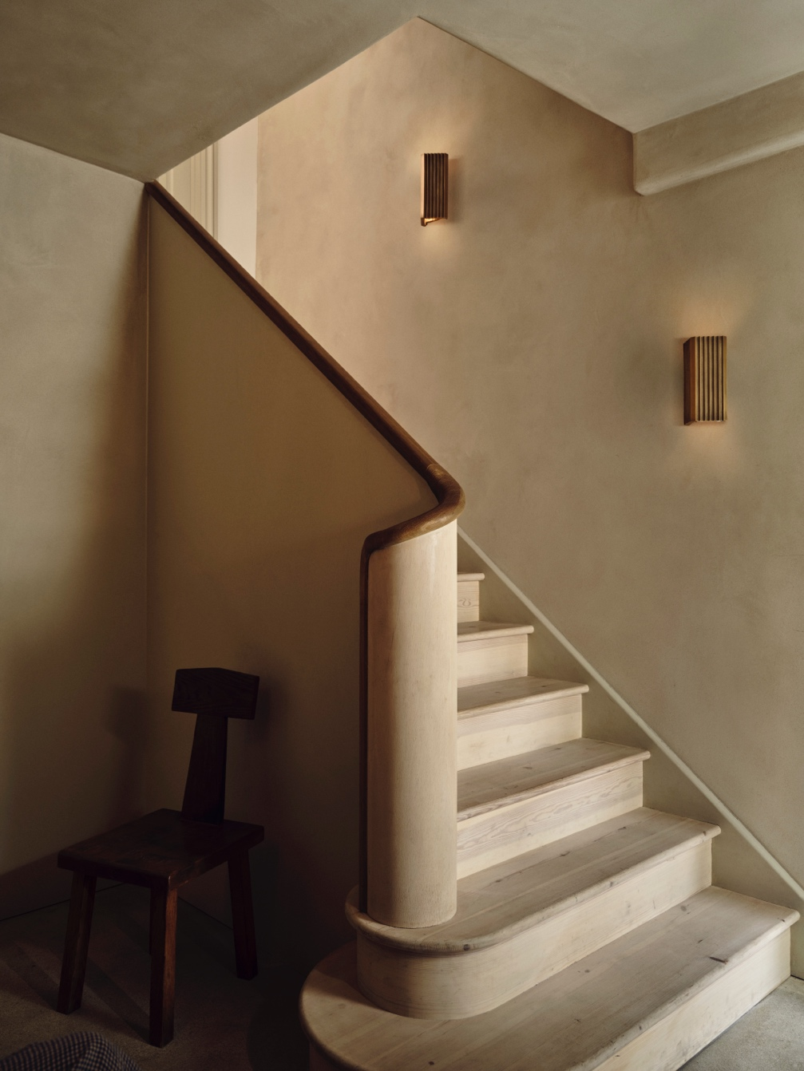

British lighting studio J. Adams & Co present Tor, their latest outdoor collection launching at Decorex International, October 2023.

Inspired by the iconic natural formations, which have long stood as symbols of enduring beauty and strength, Tor captures the essence of its namesake. Much like these grand landforms that have weathered the test of time, the Tor Wall Light is a testament to the materiality and longevity that define the brand.

A new direction for J. Adams & Co, Tor is the first collection to explore the decorative capabilities of metal casting. This centuries-old process starts by creating a mould into which molten brass is poured, taking shape as it cools. The cast pieces are then removed, refined and finished to exacting standards.

"At J. Adams & Co, we pride ourselves on blending traditional craftsmanship with innovative design, and the Tor collection is a true embodiment of that." Design Director Will Earl

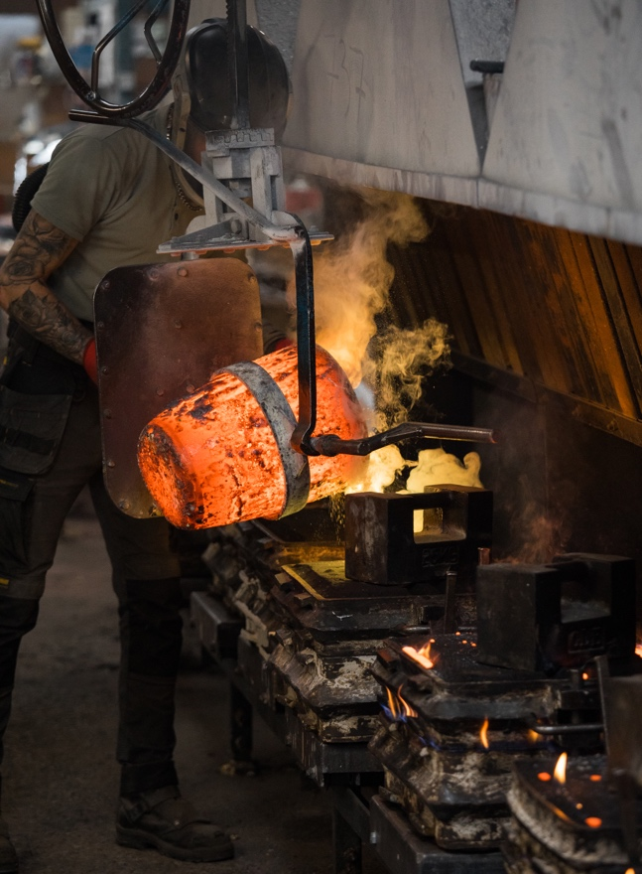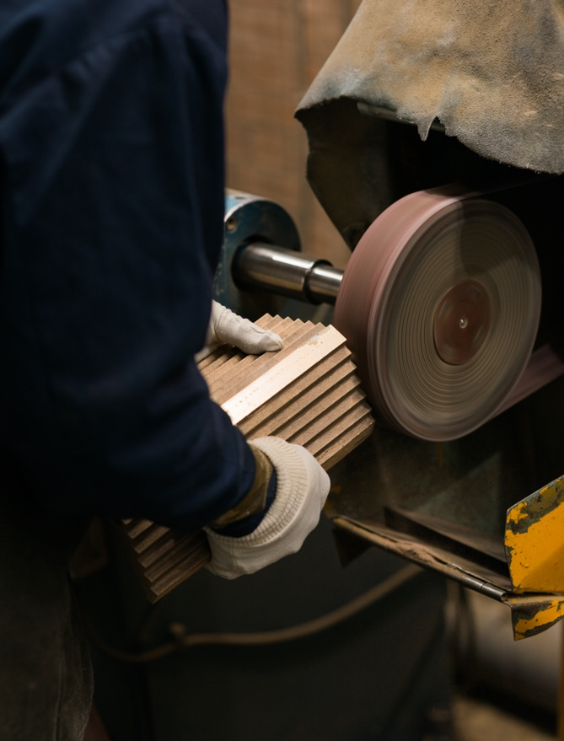

Tor ensures reliable, long-lasting illumination that can be enjoyed both indoors and outdoors, with an IP65-rating as standard. Available as a down or up and down version, greater flexibility is provided, allowing you to choose the best configuration to suit your specific requirements.

Casting both an upward and downwards illumination, Tor Up/Down beautifully washes the wall with light. When lit, Tor reveals the subtle textures and patterns of the wall, creating a decorative play of light and shadow. The two LED light sources not only offer directional light but also indirectly illuminate the surrounding space, providing an ambient glow.

The Tor Down casts a stunning downward illumination that is perfect for lighting pathways, steps and corridors. This version can also be used to accentuate architectural features, bringing both the wall and space to life.

For high resolution imagery, videos, quotes and product loans, please contact press@jadamsandco.com

Notes to Editors:
J. Adams & Co is a British lighting manufacturer that specialises in elegant luminaires of unparalleled quality. Handmade in the UK, their Birmingham factory has over half a century of manufacturing and metalworking expertise. The brand seamlessly melds traditional techniques with a nuanced, modern sensibility, focusing on craftsmanship and longevity. The result: refined and contemporary lighting that is built to last.



